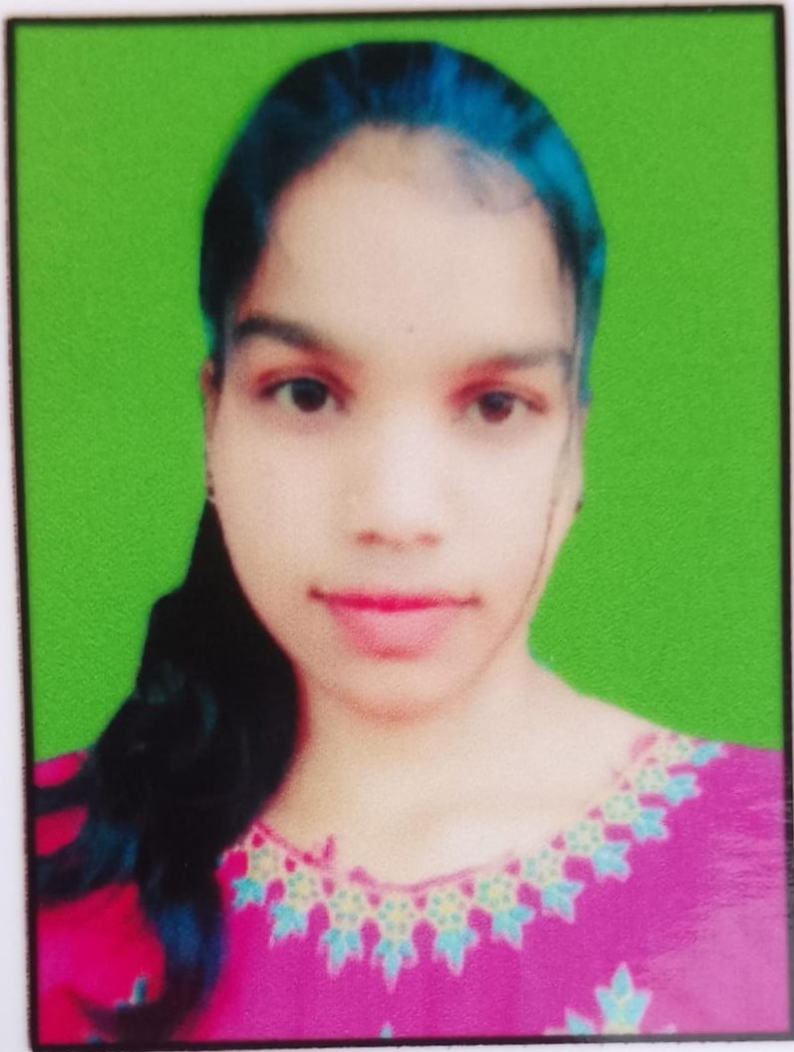

**SASWATI NAIK**

Contact no: 7894557943

Email: saswatinaik188@gmail.com

* **Career Objective:**

Seeking a challengeable position to show and utilize my skills and abilities in the corporate environment that offers me the professional growth while being resourceful, innovative and flexible.

* **Educational Qualification:**
* **Pursuing BBA 2nd year from iDream Management College, talcher, angul under utkal university Odisha, in the year 2024.**
* **Completed +2 (Intermediate Arts) from Parikul H.S. School, Paik purunakote, Odisha in the year 2023.**
* **Completed 10th from Panchayat High School, patla, Hindol under BSE, Odisha in the year of 2021.**
* **Skill Sets:**
* Packages: Microsoft Office, Adobe Photoshop
* Tally – ERP -19
* **Computer Course :**
* The Touchstone application center (Kundeswar institute patla, Dhenkanal, Odisha)
* **Strengths:**
* Excellent communication skills
* Hard work and good team player.
* Disciplined and positive thinker.
* Very professional with good attitude.
* **Hobbies:**
* Reading books, singing, Listening Music, Playing Carrom . Watching news.
* **Personal Details:**

**Fathers name** : Kanduru Naik

**Date of Birth** : 2nd June 2006

**Gender :** Female

**Religion** : Hindu

**Nationality :** Indian

**Marital Status :** Un-married

**Permanent Address :** At- Nuapada, Post- Patla, Dist- Dhenkanal,

Pin- 759121

**Languages Known :** English, Hindi and Odia

* **Declaration:**

I hereby declare that the information and facts furnished above are true, correct and complete to the best of my knowledge and belief

**SASWATI NAIK**